Reference qualifiers:
—------------------------------------------

- If a logged in user is a member of any of those 5 groups then show all groups including those 5. If a logged in user is not a member of any of those 5 groups then show all groups excluding those 5 groups.
if (grMember.hasNext()) {
return ''; // ✅ Show ALL groups
} else {
return 'sys_idNOT IN' + groupIds.join(','); // ❌ Exclude 5 groups
}
using caller field the assignement group field is queried

- We need all the Active users in the Caller Field and all users must belong to the IT Team only.
javascript: (function() {

var userIds = [];

var gr = new GlideRecord('sys_user_grmember');
gr.addQuery('group.name', 'IT Team'); // group name
gr.addQuery('user.active', true); // only active users
gr.query();

while (gr.next()) {
userIds.push(gr.user.toString());
}

if (userIds.length > 0) {
return 'sys_idIN' + userIds.join(',');
} else {
return 'sys_idIN'; // no users case
}

})();
``

- I want the VIP user available in the Caller Field of Incident Table.
vip=true
- Show users in the caller field who belong to the same department as the logged in users department.
javascript:'department=' + gs.getUser().getRecord().department
- Show only open changes in a related Change Request field.
Using condition state is not one of closed or cancelled
- We want to show/filter the users in the caller field whose location is the same as the Value of Location in the Incident Form.
javascript:'location=' + current.location
Email Scripts:
—-------------------------------------
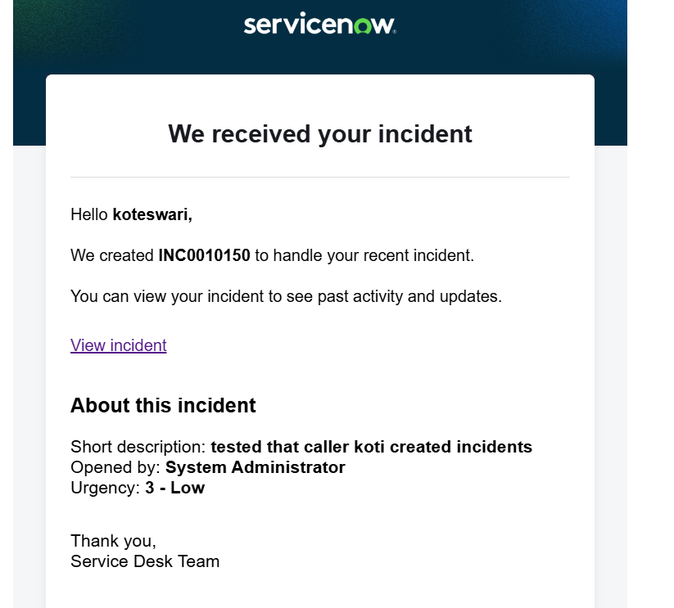
When a caller is inserted new incident trigger notification and shows them total incidents count created by caller and provides the link to see the existing incidents
using caller_incident_summary email script
(function runMailScript(/* GlideRecord */ current, /* TemplatePrinter */ template,
/* Optional EmailOutbound */ email, /* Optional GlideRecord */ email_action,
/* Optional GlideRecord */ event) {

// Add your code here

// Get caller ID
var caller = current.caller_id;

// Count total incidents created by this caller
var incGR = new GlideRecord('incident');
incGR.addQuery('caller_id', caller);
incGR.addQuery('active', true); // optional (active incidents only)
incGR.query();

var count = incGR.getRowCount();

// Display count in email
template.print("<p><b>Total Active Incidents created by you: </b>" + count + "</p>");

// Create list link
var url = gs.getProperty('glide.servlet.uri') +
"incident_list.do?sysparm_query=caller_id=" + caller;

template.print("<p>Click below to view all your incidents:</p>");
template.print("<a href='" + url + "'>View My Incidents</a>");
using notification new
Caller Incident Summary send when record is inserted or updated
caller is not empty users vinay tanneru,abel tuter
using dynamics values of that table in email body
<p>Hello ${caller_id.name},</p>

<p>Your incident <b>${number}</b> has been created successfully.</p>

${mail_script:caller_incident_summary}

<p>Thank you,<br/>Service Desk</p>

})(current, template, email, email_action, event);
Tested that new incident caller records to the existing incidents membersusing system logs and preview mail
Get the Count of Problem tickets Assigned to.
problem_count_assigned_to email script name
// Add your code here
// Get the Assigned To user (sys_user)
var assignedUser = current.assigned_to;

// GlideRecord on problem table
var prbGR = new GlideRecord('problem');
prbGR.addQuery('assigned_to', assignedUser);
prbGR.addQuery('active', true); // optional (only active problems)
prbGR.query();

// Get count
var count = prbGR.getRowCount();

// Print count in email
template.print("<p><b>Total Active Problem Tickets Assigned to You: </b>" + count + "</p>");

// Generate list view link
var url = gs.getProperty('glide.servlet.uri') +
"problem_list.do?sysparm_query=assigned_to=" + assignedUser;

template.print("<p>Click below to view your Problem tickets:</p>");
template.print("<a href='" + url + "'>View My Problems</a>");
Notification name Count of Problems Assigned to user using problem table
when the record is inserted or updated
who will receive adela cervantsz & Count of Problems Assigned To User as subject
<p>Hello ${assigned_to.name},</p>

<p>A problem record <b>${number}</b> is assigned to you.</p>

${mail_script:problem_count_assigned_to}

<p>Thank you,<br/>Service Desk</p>
using System logs record is created user assigned to and we can preview it
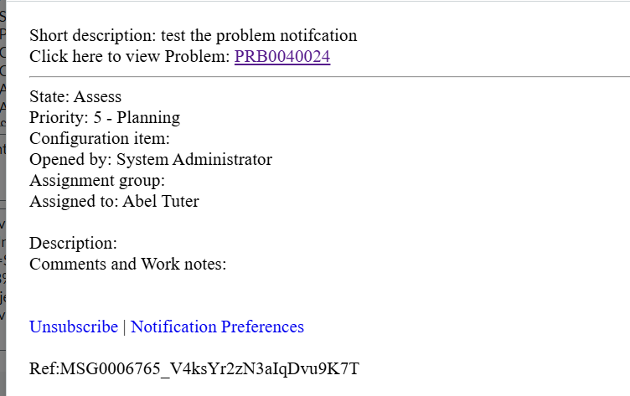

- Arrange the data in table format in email body .
get_incident_table email scripts
(function runMailScript(current, template, email, email_action, event) {

// 1. Query the target table (Example: Incidents opened by the same caller)
var gr = new GlideRecord('incident');
gr.addQuery('caller_id', current.caller_id);
gr.addActiveQuery();
gr.setLimit(5); // Limit rows for email cleanliness
gr.query();

// 2. Define the inline CSS styles for clean rendering in Outlook/Gmail
var tableStyle = 'border-collapse: collapse; width: 100%; font-family: Arial, sans-serif; font-size: 14px;';
var thStyle = 'background-color: #1f3a60; color: #ffffff; padding: 10px; border: 1px solid #dddddd; text-align: left;';
var tdStyle = 'padding: 10px; border: 1px solid #dddddd;';

// 3. Start building the HTML Table structure
var htmlTable = '<table style="' + tableStyle + '" cellpadding="8" cellspacing="0">';
htmlTable += '<thead><tr>';
htmlTable += '<th style="' + thStyle + '">Number</th>';
htmlTable += '<th style="' + thStyle + '">Short Description</th>';
htmlTable += '<th style="' + thStyle + '">State</th>';
htmlTable += '<th style="' + thStyle + '">Priority</th>';
htmlTable += '</tr></thead>';
htmlTable += '<tbody>';

// 4. Loop through records and dynamically add rows
var hasRecords = false;
while (gr.next()) {
hasRecords = true;
htmlTable += '<tr>';
htmlTable += '<td style="' + tdStyle + '">' + gr.getValue('number') + '</td>';
htmlTable += '<td style="' + tdStyle + '">' + gr.getDisplayValue('short_description') + '</td>';
htmlTable += '<td style="' + tdStyle + '">' + gr.getDisplayValue('state') + '</td>';
htmlTable += '<td style="' + tdStyle + '">' + gr.getDisplayValue('priority') + '</td>';
htmlTable += '</tr>';
}
htmlTable += '</tbody></table>';

// 5. Print to the email if data exists, otherwise print a fallback message
if (hasRecords) {
template.print(htmlTable);
} else {
template.print('<p style="font-family: Arial; font-size: 14px;">No active incidents found.</p>');
}

})(current, template, email, email_action, event);
and created a notification using incident table and record is inserted
${mail_script:get_incident_table}

